BUGS

**Bug-1**

We encountered an error while performing the search. For example, when we searched for the word "one", we were getting the meanings of the word "bone". The reason for this error was because the word "bone" had the word "one" in it and the word “bone” was in the file before the word “one”. For this reason, we put the "%%" sign in front of the word we want to search. Thanks to this sign, we could distinguish the word we wanted to search from other words.

**Bug-2**

In the file, some words had more than one meaning. These meanings indicated by the 1., 2., 3., marks placed in front of them. However, these numbers gave us trouble. For example, when we enter the word “bir” it was printed as "1.one" because the word "one" has more than one meaning in English. And this cause a big problem. Since we did not use the Turkish-French folder, it would go from Turkish to English and then from English to French. Finally, when translating into French, it was searched as "1. one" in the English class. To solve this problem, We accepted "1." as a word and first word after then this word will be transleted. After doing this process, we have now searched for only "one" instead of "1. one" when translating from Turkish to English. As a result, when we searched for the word "one", we managed to get a proper French equivalent.

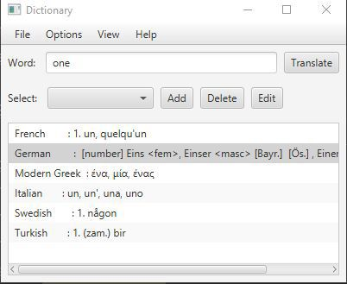

**Bug-3**

For example, when we type "asia" while searching, we could only get the Turkish meaning, but when we wrote "Asia", we could get the meanings in other languages, but it did not come in Turkish. For this, we decided to write all the words in lower case. As a result, we were able to get the meanings in all languages, whether the first letters were entered in uppercase or lowercase. We solved this problem with the toLowerCase method. We converted all letters of the word we entered into lowercase with the toLowerCase method and printed the results.

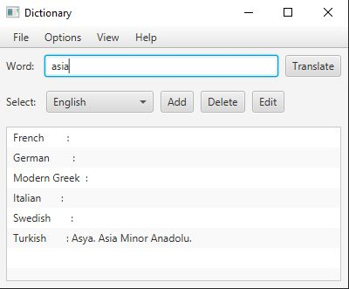 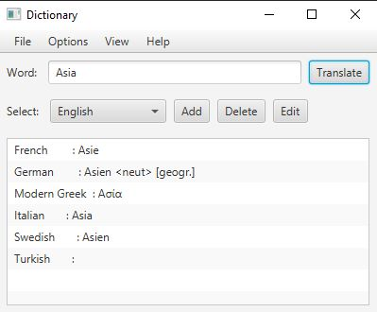

**Bug-4**

We had some difficulties while categorizing the extensions of the files into an array. Because some languages didn't have translations to all languages, or because there would not be the same language-tr/tr- translations, we needed to return null values for these files. But the system stopped searching other files when it saw null. For example, suppose we are translating from the German language. Since there will be no re-translation of German into its own language, null value has been assigned here and this value will be in the 3rd rank. While the user was able to see the translation in the first two languages while getting the translation of the word he entered, he could not see the third and the following. We solved this using an if-else construct with 'continue', which indicates that it should continue when it sees a null value. In other words, when it saw a null value, we were able to continue the search from the file below it.

**Bug-5**

We encountered this issue where the user was searching without language selection. Because the program did not know in which files this word would be searched. To solve this, we set English by default. In other words, if there was no language selection when the program was first opened, the translations of the directly entered word -if any- from English to other languages became visible.

**Bug-6**

First, we separated the word we were searching from other words with the "-" sign. (For the words that would cause the error in the “one” and “bone” example). But when we entered the word “dog”, a different meanings printed. The reason for this was the word "dog-eat-dog". We noticed that the hyphen would cause problems in such cases, we decided to put the "%%" sign, which does not cause us any trouble. So we have solved this problem.

